# LABSHEET 1: INTRODUCTION TO 8085 MICROPROCESSORS

**Name: Vinayak V Thayil Roll Number: AM.EN.U4CSE21161**

1. Convert the binary number 01000101 to hexadecimal.

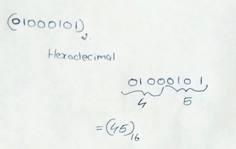

1. Convert the hex number 0x63F to binary.

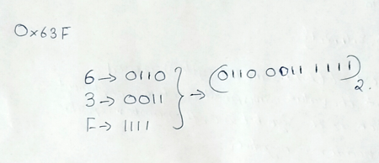

1. Give the signed representations of the decimal 45 in 8-bit binary and hexadecimal.

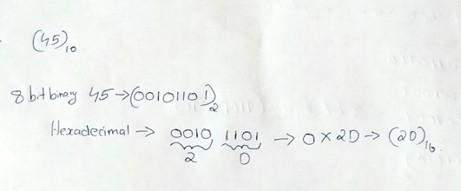

1. Specify the signed and unsigned decimal representations of the 8-bit hex number 0x95.

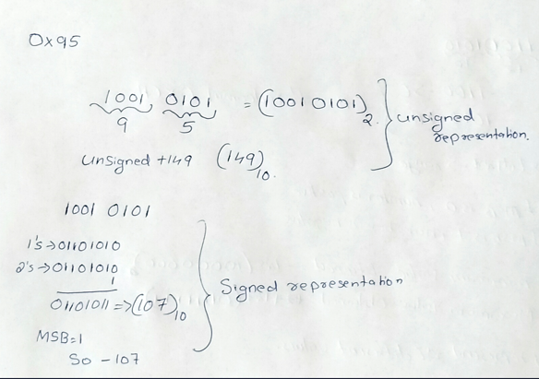

1. Convert the signed binary number (11011010)2 to signed decimal.

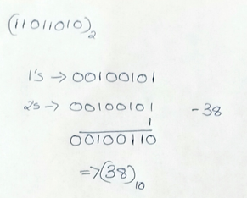

1. For the unsigned 8-bit number system, the basis elements are {128,64,32,16,8,4,2,1}. What are the basis elements of signed 8-bit number system?

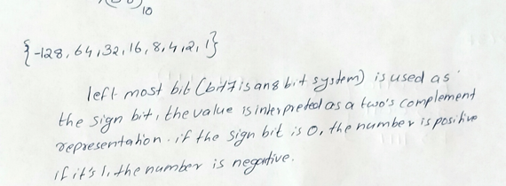

1. Give the representations of -54 in 8-bit binary and hexadecimal.

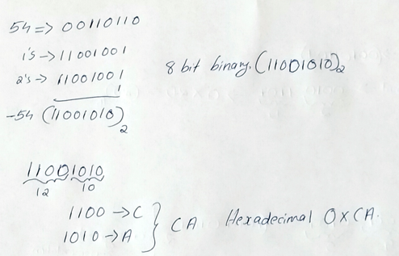

1. What are the possible values of 8-bit signed numbers?

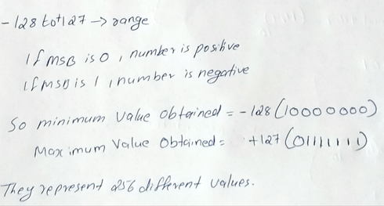

1. What are the possible values of 8-bit unsigned numbers?\

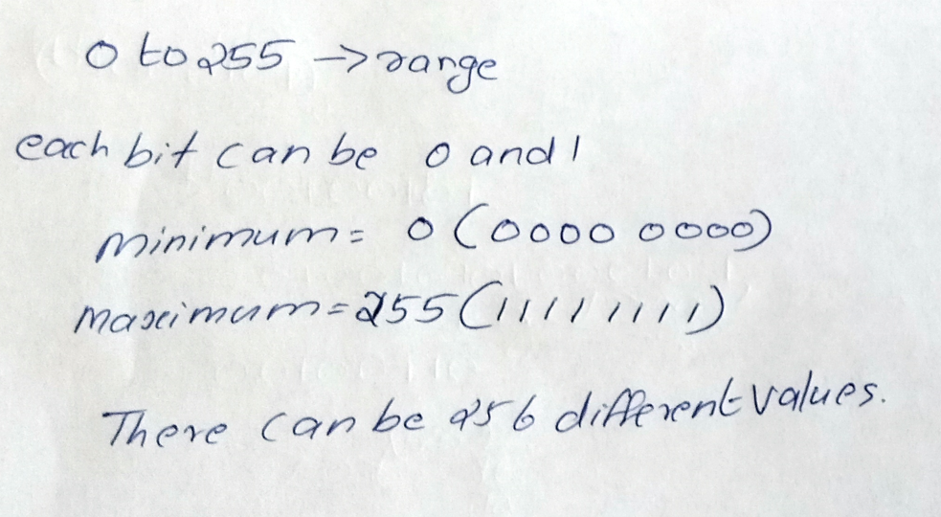

1. Download a simulator for simple 8-bit processor 8085 in the below link <https://gnusim8085.github.io/>
2. Fill the machine code for the following assembly program

|  |  |  |  |  |
| --- | --- | --- | --- | --- |
| **Assembly** | **Instruction size** | **Memory Address** | **Object Binary Code** | **Object Code in Hex** |
| **Code1:** MVI A, 32H  MVI B, 48H  ADD B  OUT 01H  HLT | 2 bytes  2 bytes  1 byte  2 bytes  1 bytes | 4200  4202  4204  4205  4207 | 0011 1110 0011 0010  0000 0110 0100 1000  1000 0000  1101 0011 0000 0001  0111 0110 | 3E 32  06 48  80  D3 01  76 |
| **Code2:** MVI A,01H STA 4500H HLT | 2 bytes  3 bytes  1 byte | 4200  4202  4205 | 0110 1110 0000 0001  0011 0010 0000 0000  0100 0101  0111 0110 | 3E 01  32 00 045  76 |

|  |  |  |  |  |
| --- | --- | --- | --- | --- |
| **Code 3:** LDA 1000H    MOV B, A  LDA 2000H  STA 1000H  MOV A, B  STA 2000H  HLT | 3bytes  1 byte  3 bytes  3 bytes  1 byte  3 bytes  1 byte | 4200  4203  4204  4207  420A  420B  420E | 0011 1010 0000 0000  0001 0000  0100 0111  0011 1010 0000 0000  0010 0000  0011 0010 0000 0000  0001 0000  0111 1000  0011 0010 0000 0000  0010 0000  0111 0110 | 3A 00 010  47  3A 00 020  32 00 010  78  32 00 020  76 |
| **Code 4:** MVI A,55H CMA  STA 1001H  MVI A,00H  HLT | 2 bytes  1 byte  3 bytes  2 bytes  1 byte | 4200  4202  4203  4206  4208 | 0011 1110 0101 0101  0010 1111  0011 0010 0000 0001  0001 0000  0011 1110 0000 0000  0111 0110 | 3E 55  2F  32 01 010  3E 00  76 |